Aim: To implement Regression in Python.

Theory:
Q1. What is Regression?
Regression is a statistical and machine learning technique used to model the relationship between a dependent variable (output) and one or more independent variables (inputs), mainly for prediction and trend analysis.

Q2. List applications of Regression.
- Predicting house prices
- Sales and revenue forecasting
- Stock market trend analysis
- Demand prediction in businesses
- Risk assessment in finance
- Weather forecasting
- Healthcare outcome prediction

Q3. List and explain any 3 types of Regression.
- 1. Linear Regression:
Models a straight-line relationship between input and output.
Example: Predicting salary based on experience.
- 2. Logistic Regression:
Used for classification problems (outputs probability between 0 and 1).
Example: Spam vs Not Spam.
- 3. Ridge Regression:
An extension of linear regression that adds a penalty to reduce overfitting.
Example: Used when data has noise or multicollinearity.

Q4. List metrics to evaluate a regression model.
Metric | Meaning
MAE (Mean Absolute Error) | Average absolute difference between actual and predicted values
MSE (Mean Squared Error) | Average of squared errors
RMSE (Root Mean Squared Error) | Square root of MSE (same units as output)
R² Score | Proportion of variance explained by the model
Adjusted R² | Modified R² considering number of features

Q5. Write a Python program to implement the Linear Regression.
Code:
df = pd.read_csv('games_data.csv')

num_cols = df.select_dtypes(include=[np.number]).columns.tolist()
X = df[[num_cols[0]]].values
y = df[num_cols[1]].values

X_b = np.c_[np.ones((len(X),1)), X]
theta = np.linalg.pinv(X_b.T @ X_b) @ X_b.T @ y
y_pred = X_b @ theta

plt.figure()
plt.scatter(X, y)
plt.plot(X, y_pred)
plt.title('Linear Regression')
plt.xlabel(num_cols[0])
plt.ylabel(num_cols[1])
plt.show()

R = np.corrcoef(X.flatten(), y)[0,1]
print("R =", R)

Output:
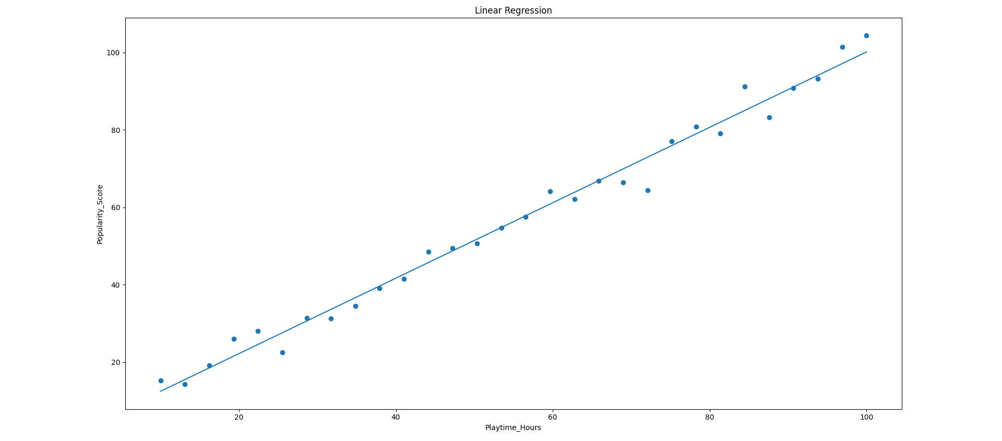
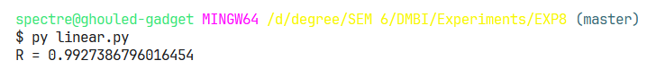

Q6. Write a Python program to implement the Logistic Regression.
Code:
df = pd.read_csv('games_data.csv')

num_cols = df.select_dtypes(include=[np.number]).columns.tolist()
X = df[[num_cols[0]]].values
y = df[num_cols[1]].values

y_bin = (y > np.median(y)).astype(int)

X_b = np.c_[np.ones((len(X),1)), X]
w = np.zeros(X_b.shape[1])
lr = 0.01

for _ in range(500):
z = X_b @ w
h = 1/(1+np.exp(-z))
grad = X_b.T @ (h - y_bin) / len(y_bin)
w -= lr * grad

y_pred = 1/(1+np.exp(-(X_b @ w)))

plt.figure()
plt.scatter(X, y_bin)
plt.plot(X, y_pred)
plt.title('Logistic Regression')
plt.xlabel(num_cols[0])
plt.ylabel('Binary Target')
plt.show()

R = np.corrcoef(X.flatten(), y)[0,1]
print("R =", R)

Output:
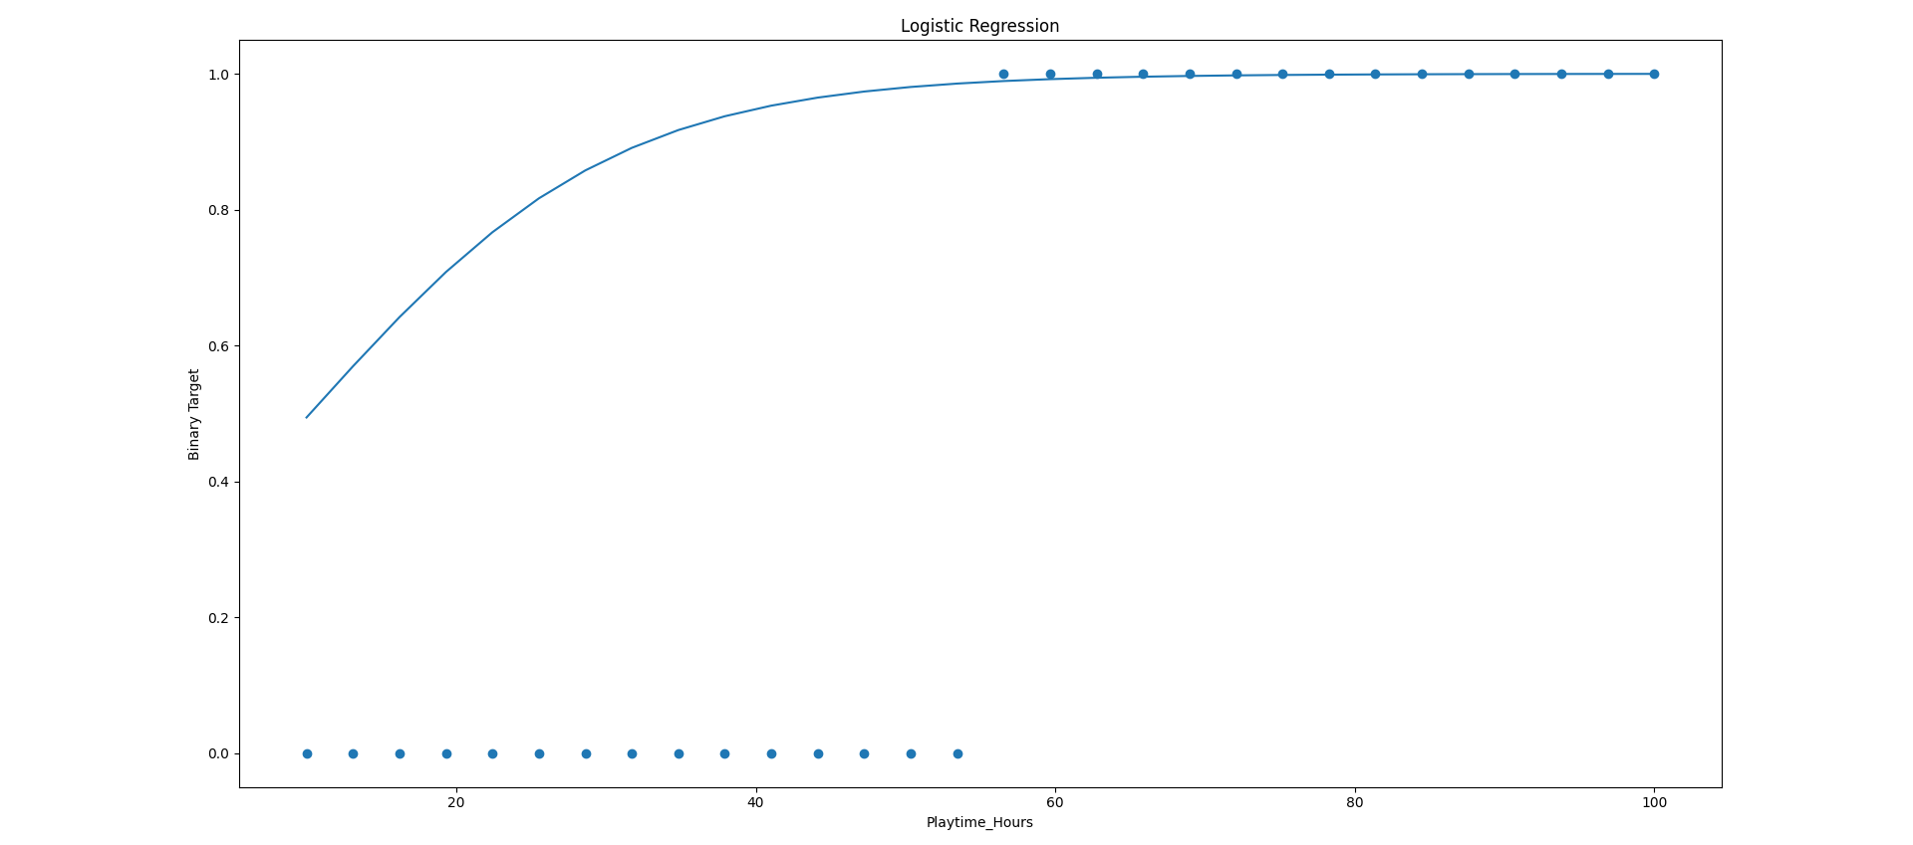
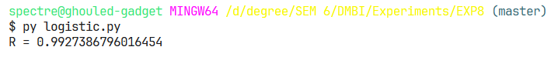

Q7. Write a Python program to implement Ridge Regression.
Code:
df = pd.read_csv('games_data.csv')

num_cols = df.select_dtypes(include=[np.number]).columns.tolist()
X = df[[num_cols[0]]].values
y = df[num_cols[1]].values

X_b = np.c_[np.ones((len(X),1)), X]
lam = 1.0
I = np.eye(X_b.shape[1]); I[0,0] = 0
theta = np.linalg.pinv(X_b.T @ X_b + lam*I) @ X_b.T @ y
y_pred = X_b @ theta

plt.figure()
plt.scatter(X, y)
plt.plot(X, y_pred)
plt.title('Ridge Regression')
plt.xlabel(num_cols[0])
plt.ylabel(num_cols[1])
plt.show()

R = np.corrcoef(X.flatten(), y)[0,1]
print("R =", R)

Output:
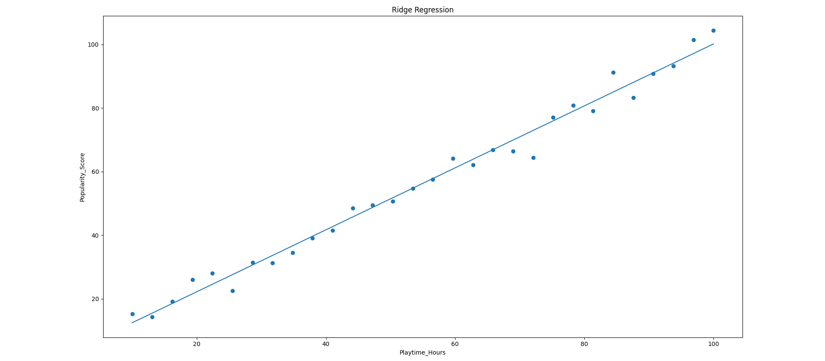
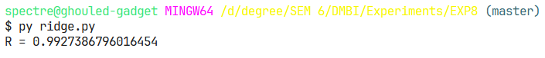

Conclusion:
The Apriori algorithm effectively uncovers hidden purchasing patterns, enabling data-driven cross-selling strategies and optimized product placements.

